**WEEK 3**

**Spring Core and Maven**

**EXERCISE 1:Spring Core and Maven**

**Pom.xml**

<project xmlns="http://maven.apache.org/POM/4.0.0"

         xmlns:xsi="http://www.w3.org/2001/XMLSchema-instance"

         xsi:schemaLocation="http://maven.apache.org/POM/4.0.0

                             http://maven.apache.org/xsd/maven-4.0.0.xsd">

    <modelVersion>4.0.0</modelVersion>

    <groupId>com.library</groupId>

    <artifactId>LibraryManagement</artifactId>

    <version>1.0-SNAPSHOT</version>

    <dependencies>

        <dependency>

            <groupId>org.springframework</groupId>

            <artifactId>spring-context</artifactId>

            <version>5.3.30</version>

        </dependency>

    </dependencies>

    <build>

        <plugins>

            <!-- Exec plugin for running the main class -->

            <plugin>

                <groupId>org.codehaus.mojo</groupId>

                <artifactId>exec-maven-plugin</artifactId>

                <version>3.1.0</version>

            </plugin>

        </plugins>

    </build>

</project>

**applicationContext.xml**

<?xml version="1.0" encoding="UTF-8"?>

<beans xmlns="http://www.springframework.org/schema/beans"

       xmlns:xsi="http://www.w3.org/2001/XMLSchema-instance"

       xsi:schemaLocation="

           http://www.springframework.org/schema/beans

           http://www.springframework.org/schema/beans/spring-beans.xsd">

    <bean id="bookRepository" class="com.library.repository.BookRepository"/>

    <bean id="bookService" class="com.library.service.BookService">

        <property name="bookRepository" ref="bookRepository"/>

    </bean>

</beans>

BookRepository.java

package com.library.repository;

public class BookRepository {

    public void saveBook(String title) {

        System.out.println("Saving book: " + title);

    }

}

**BookService.java**

package com.library.service;

import com.library.repository.BookRepository;

public class BookService {

    private BookRepository bookRepository;

    // Setter for Spring injection

    public void setBookRepository(BookRepository bookRepository) {

        this.bookRepository = bookRepository;

    }

    public void addBook(String bookName) {

        bookRepository.save(bookName);

    }

}

**MainApp.java**

package com.library;

import org.springframework.context.ApplicationContext;

import org.springframework.context.support.ClassPathXmlApplicationContext;

import com.library.service.BookService;

public class MainApp {

    public static void main(String[] args) {

        ApplicationContext context = new ClassPathXmlApplicationContext("applicationContext.xml");

        BookService service = context.getBean("bookService", BookService.class);

        service.addBook("The Great Gatsby");

    }

}

**Output:**

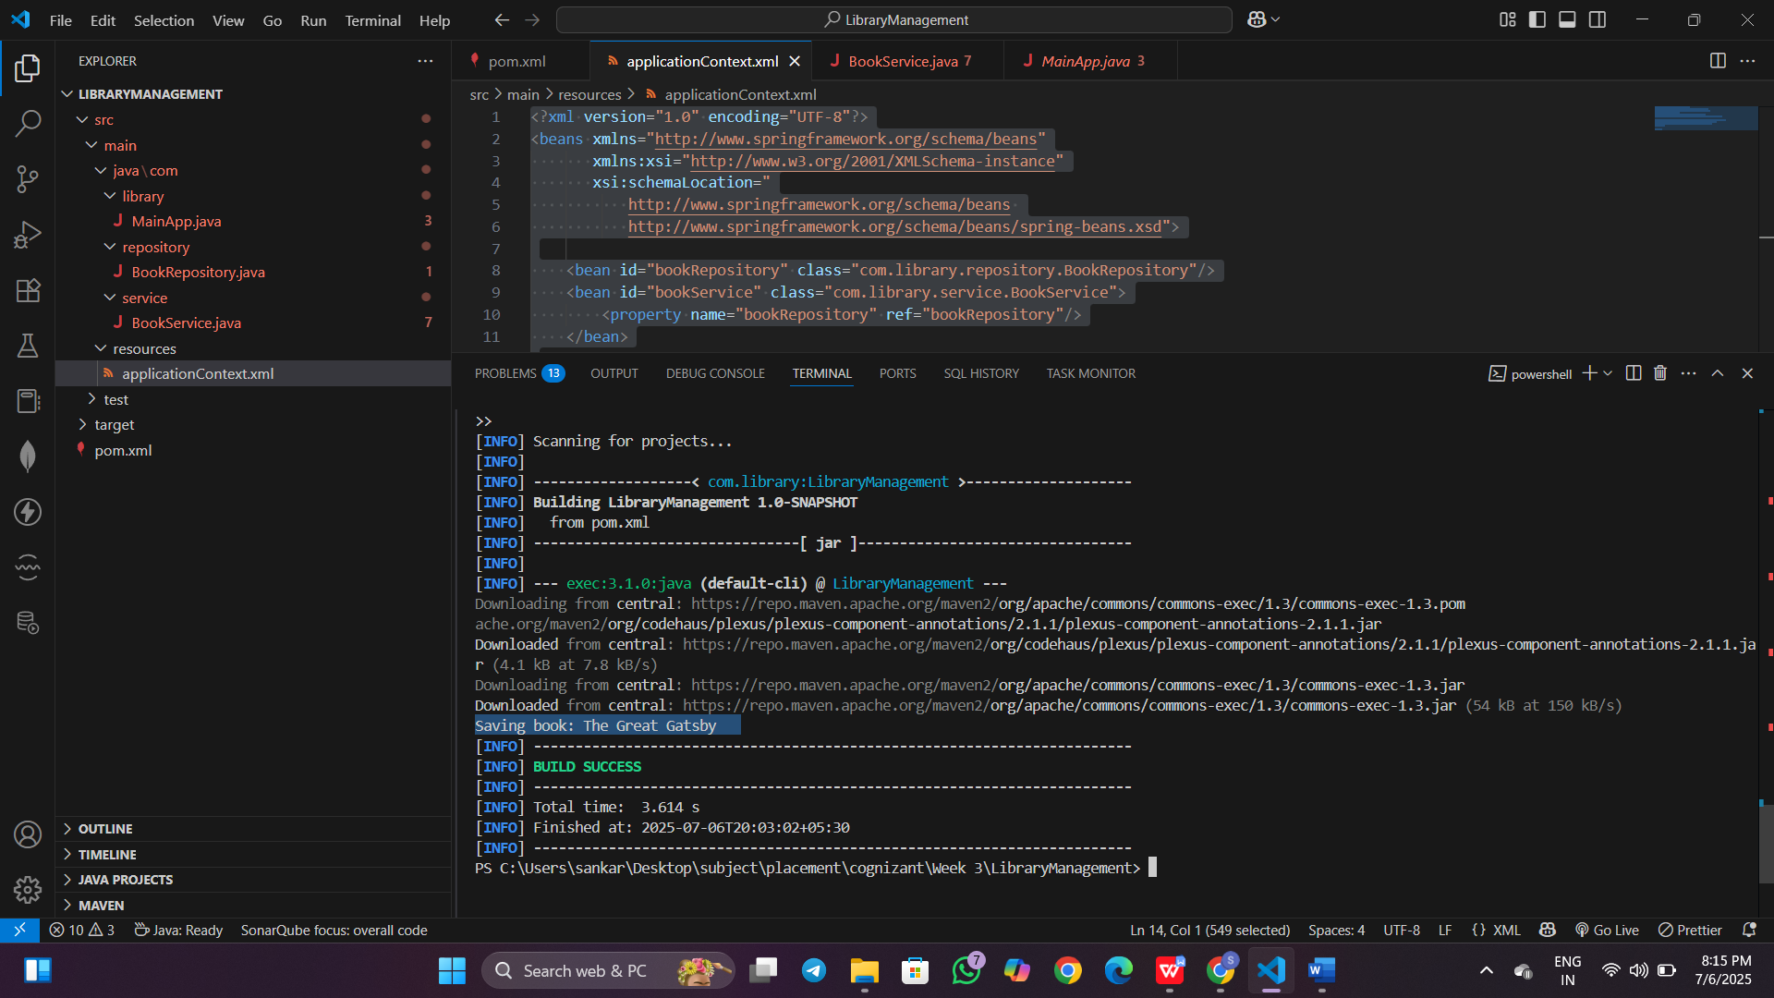

**Exercise 2: Implementing Dependency Injection**

**applicationContext.xml**

<?xml version="1.0" encoding="UTF-8"?>

<beans xmlns="http://www.springframework.org/schema/beans"

       xmlns:xsi="http://www.w3.org/2001/XMLSchema-instance"

       xsi:schemaLocation="

           http://www.springframework.org/schema/beans

           http://www.springframework.org/schema/beans/spring-beans.xsd">

    <!-- BookRepository Bean -->

    <bean id="bookRepository" class="com.library.repository.BookRepository" />

    <!-- BookService Bean with Setter Injection -->

    <bean id="bookService" class="com.library.service.BookService">

        <property name="bookRepository" ref="bookRepository"/>

    </bean>

</beans>

**applicationContext.xml**

<?xml version="1.0" encoding="UTF-8"?>

<beans xmlns="http://www.springframework.org/schema/beans"

       xmlns:xsi="http://www.w3.org/2001/XMLSchema-instance"

       xsi:schemaLocation="

           http://www.springframework.org/schema/beans

           http://www.springframework.org/schema/beans/spring-beans.xsd">

    <bean id="bookRepository" class="com.library.repository.BookRepository"/>

    <bean id="bookService" class="com.library.service.BookService">

        <property name="bookRepository" ref="bookRepository"/>

    </bean>

</beans>

**BookRepository.java**

package com.library.repository;

public class BookRepository {

    public void save(String bookName) {

        System.out.println("Saving book: " + bookName);

    }

}

**BookService.java**

package com.library.service;

import com.library.repository.BookRepository;

public class BookService {

    private BookRepository bookRepository;

    // Setter for DI

    public void setBookRepository(BookRepository bookRepository) {

        this.bookRepository = bookRepository;

    }

    public void addBook(String bookName) {

        bookRepository.save(bookName);

    }

}

**MainApp.java**

package com.library;

import com.library.service.BookService;

import org.springframework.context.ApplicationContext;

import org.springframework.context.support.ClassPathXmlApplicationContext;

public class MainApp {

    public static void main(String[] args) {

        ApplicationContext context = new ClassPathXmlApplicationContext("applicationContext.xml");

        BookService bookService = (BookService) context.getBean("bookService");

        bookService.addBook("Spring in Action");

    }}

Test/MainApp.java

package com.library;

import com.library.service.BookService;

import org.springframework.context.ApplicationContext;

import org.springframework.context.support.ClassPathXmlApplicationContext;

public class MainApp {

    public static void main(String[] args) {

        ApplicationContext context = new ClassPathXmlApplicationContext("applicationContext.xml");

        BookService bookService = context.getBean("bookService", BookService.class);

  // Test injection

        bookService.addBook("Spring in Action");

    }}

**Output:**

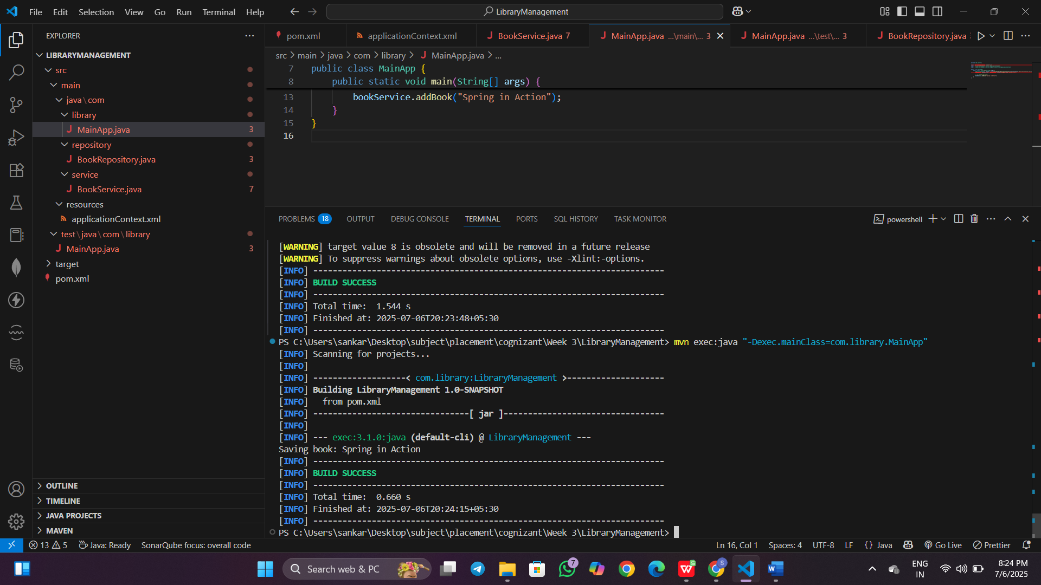

**Exercise 4: Creating and Configuring a Maven Project**

**Pom.xml**

<project xmlns="http://maven.apache.org/POM/4.0.0"

         xmlns:xsi="http://www.w3.org/2001/XMLSchema-instance"

         xsi:schemaLocation="http://maven.apache.org/POM/4.0.0 http://maven.apache.org/xsd/maven-4.0.0.xsd">

    <modelVersion>4.0.0</modelVersion>

   <groupId>com.library</groupId>

    <artifactId>LibraryManagement</artifactId>

    <version>1.0-SNAPSHOT</version>

    <properties>

        <maven.compiler.source>1.8</maven.compiler.source>

        <maven.compiler.target>1.8</maven.compiler.target>

    </properties>

    <dependencies>

        <dependency>

            <groupId>org.springframework</groupId>

            <artifactId>spring-context</artifactId>

            <version>5.3.22</version>

        </dependency>

        <dependency>

            <groupId>org.springframework</groupId>

            <artifactId>spring-aop</artifactId>

            <version>5.3.22</version>

        </dependency>

        <dependency>

            <groupId>org.springframework</groupId>

            <artifactId>spring-webmvc</artifactId>

            <version>5.3.22</version>

        </dependency>

    </dependencies>

    <build>

        <plugins>

            <!-- Compiler Plugin -->

            <plugin>

                <groupId>org.apache.maven.plugins</groupId>

                <artifactId>maven-compiler-plugin</artifactId>

                <version>3.8.1</version>

                <configuration>

                    <source>1.8</source>

                    <target>1.8</target>

                </configuration>

            </plugin>

            <!-- Exec Plugin to run Java class -->

            <plugin>

                <groupId>org.codehaus.mojo</groupId>

                <artifactId>exec-maven-plugin</artifactId>

                <version>3.1.0</version>

                <configuration>

                    <mainClass>com.library.LibraryApp</mainClass>

                </configuration>

            </plugin>

        </plugins>

    </build>

</project>

**LibraryApp.java**package com.library;

import org.springframework.context.ApplicationContext;

import org.springframework.context.support.ClassPathXmlApplicationContext;

public class LibraryApp {

    public static void main(String[] args) {

        System.out.println("Library Management Application Started");

        ApplicationContext context = new ClassPathXmlApplicationContext("applicationContext.xml");

        System.out.println("Spring Context Initialized");

    }}

Output:

